BIOLOGY DEPARTMENT
NAMUNGOONA SALAF SEC. SCH
GASEOUS EXCHANGE. Thur, June 25th,2020

Section B (40mrks)
Instructions
- Answer all questions in section B
- Answer any two questions from section C
Note.
After answering the questions take a picture of your work and send to the WhatsApp number above

1. A study was carried out on a an athlete who was under an exercise. The changes in the breathing rate and the rate of heart beat were monitored. The results were reflected in the graphs (a) and (b)

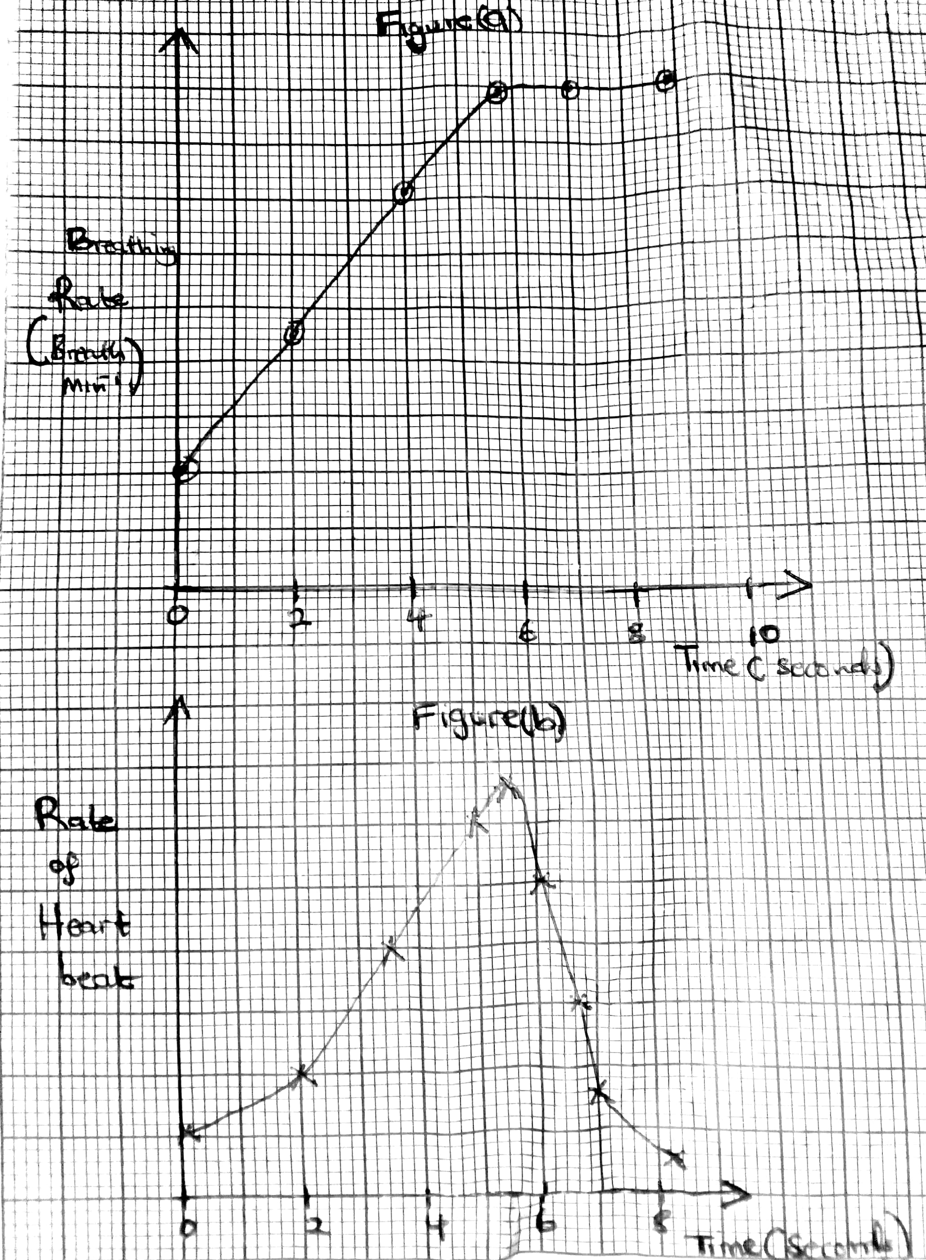

a) Describe what is happening in each graph
I) Graph (a) (03mrks)
..........................................................................................................
..........................................................................................................
.........................................................................................................
.........................................................................................................
ii) Figure (b) (04mrks)
........................................................................................................
........................................................................................................
........................................................................................................
........................................................................................................
b) Give an explanation for the observation shown in figure (a) (03mrks)
.......................................................................................................
.......................................................................................................
.......................................................................................................
.......................................................................................................
c) From figure (b), what is the significance of increase in the the rate of heart beat during an exercise (05mrks)
.....................................................................................................
.....................................................................................................
.....................................................................................................
......................................................................................................
.......................................................................................................
........................................................................................................
di) State any three other changes that occur in a human body during an exercise apart from those in figure (b) and (a)
....................................................................................................
....................................................................................................
....................................................................................................
ii) Draw graph on figure (a) to show how the breathing rate of non athlete will change during the exercise (02mrks)
2. The figure below is an apparatus that is used to demonstrate breathing mechanism in a mammal

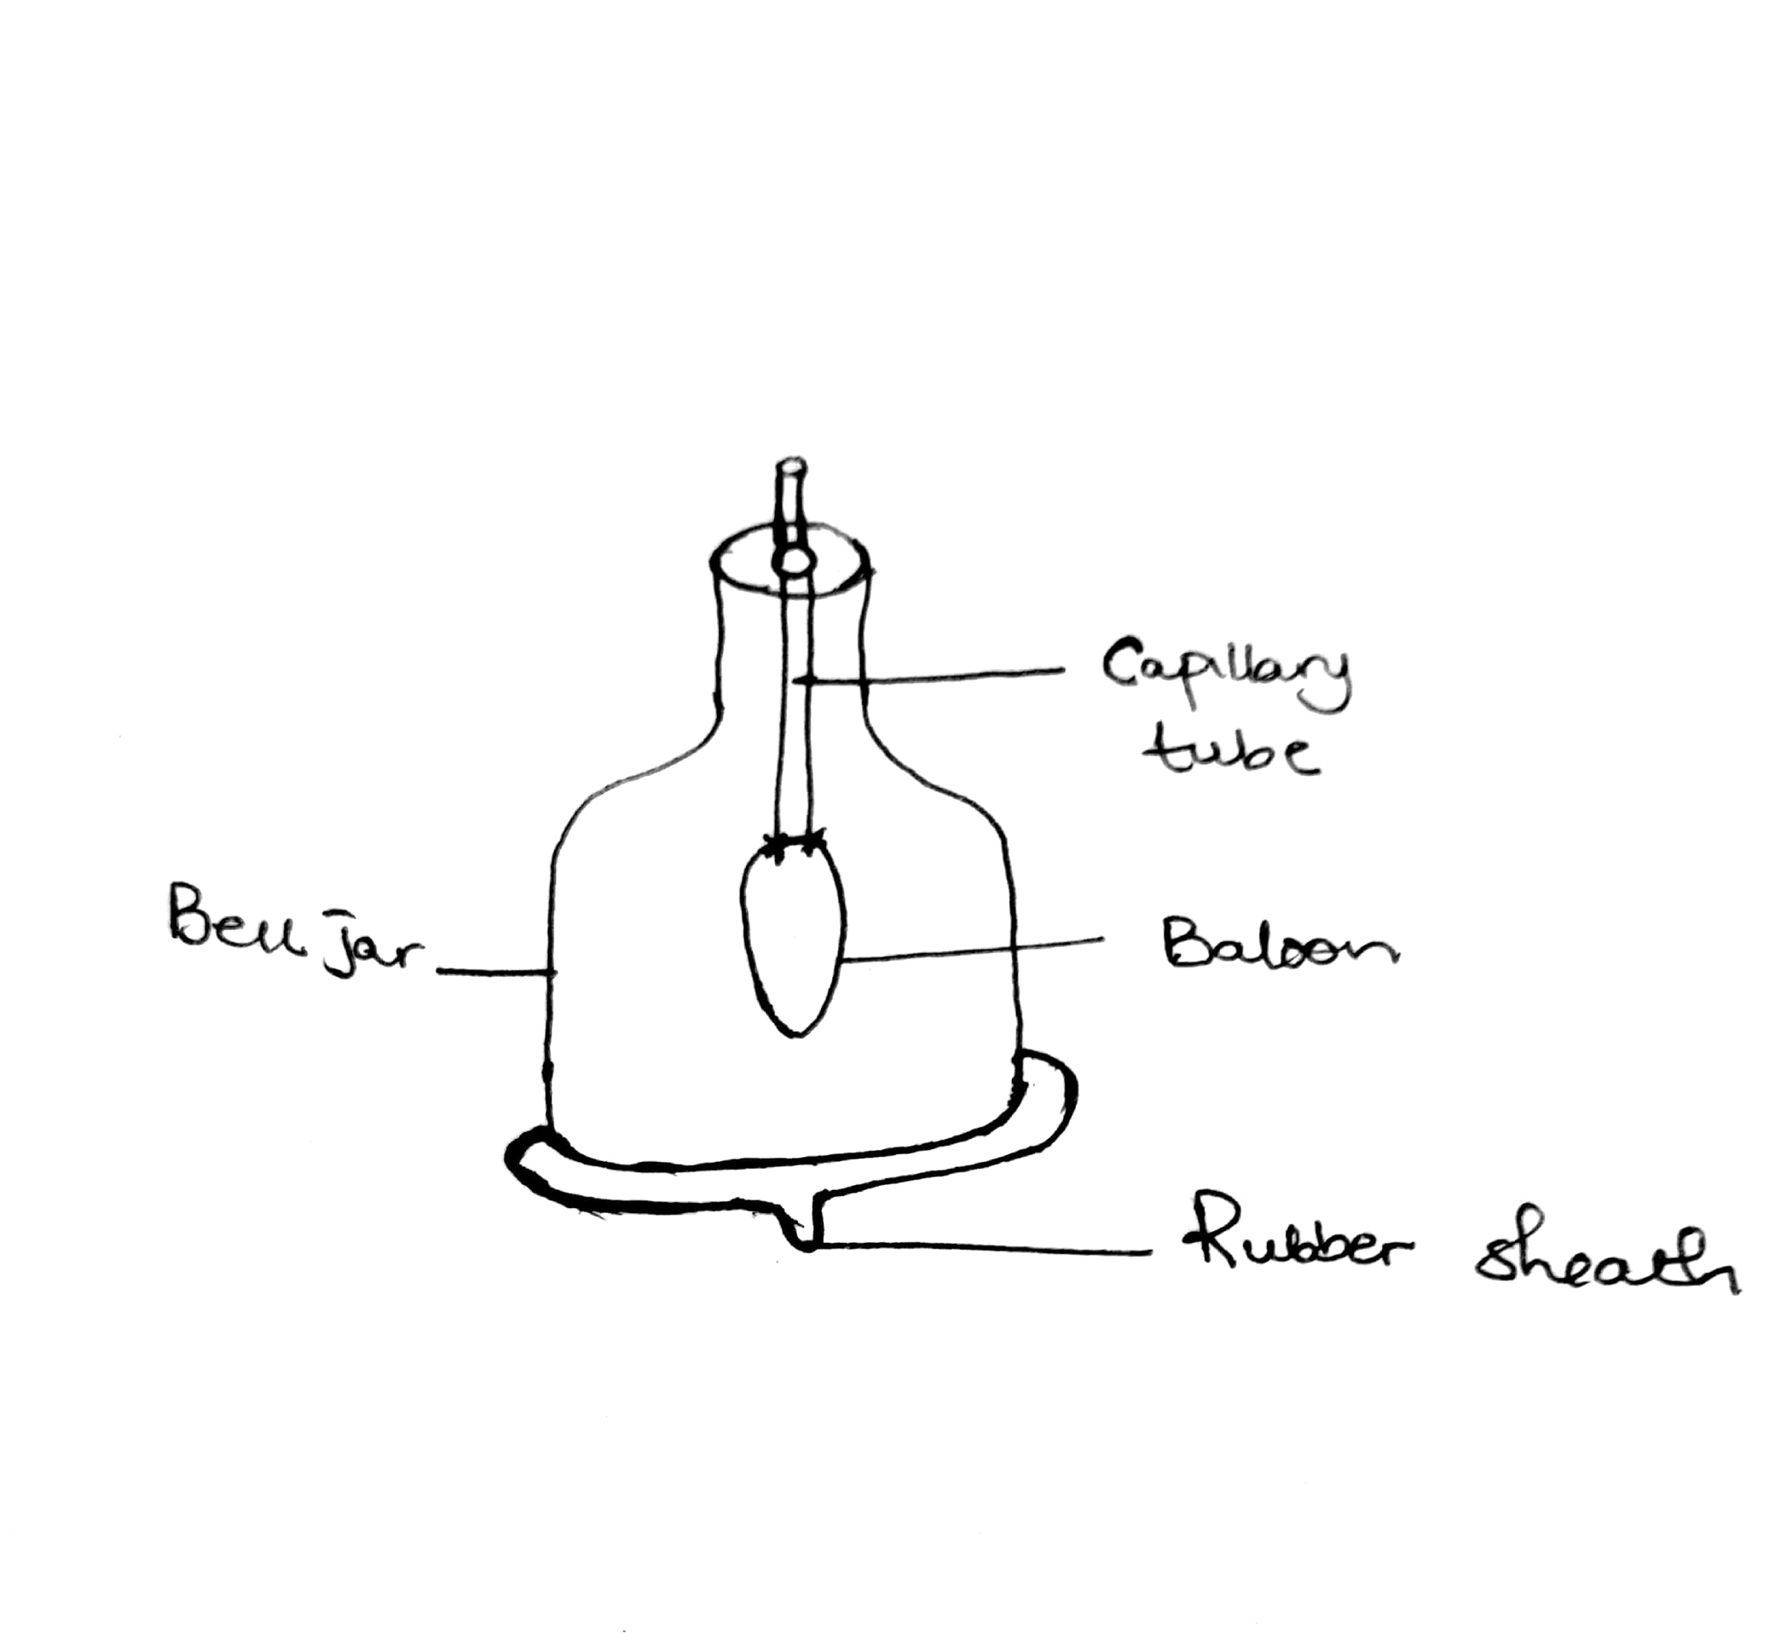
a) Describe what happens when the rubber sheath is pulled downwards (03mrks)
........................................................................................................
.......................................................................................................
.....................................................................................................
....................................................................................................
b) What do the following parts represent in a mammal (1½mrks)
I) Balloon
..............................................................................
ii) Rubber sheath
..............................................................................
ii) Capillary tube
.........................................................................

c) What does this mechanism lack to give an accurate demonstration of the breathing mechanism (02mrks)
.........................................................................................................
........................................................................................................
.......................................................................................................
.......................................................................................................
d) A student setup an experiment to investigate some aspect of gaseous exchange using the apparatus represented below
The student placed the mouth at tube P and breathed in and out several times through the tube

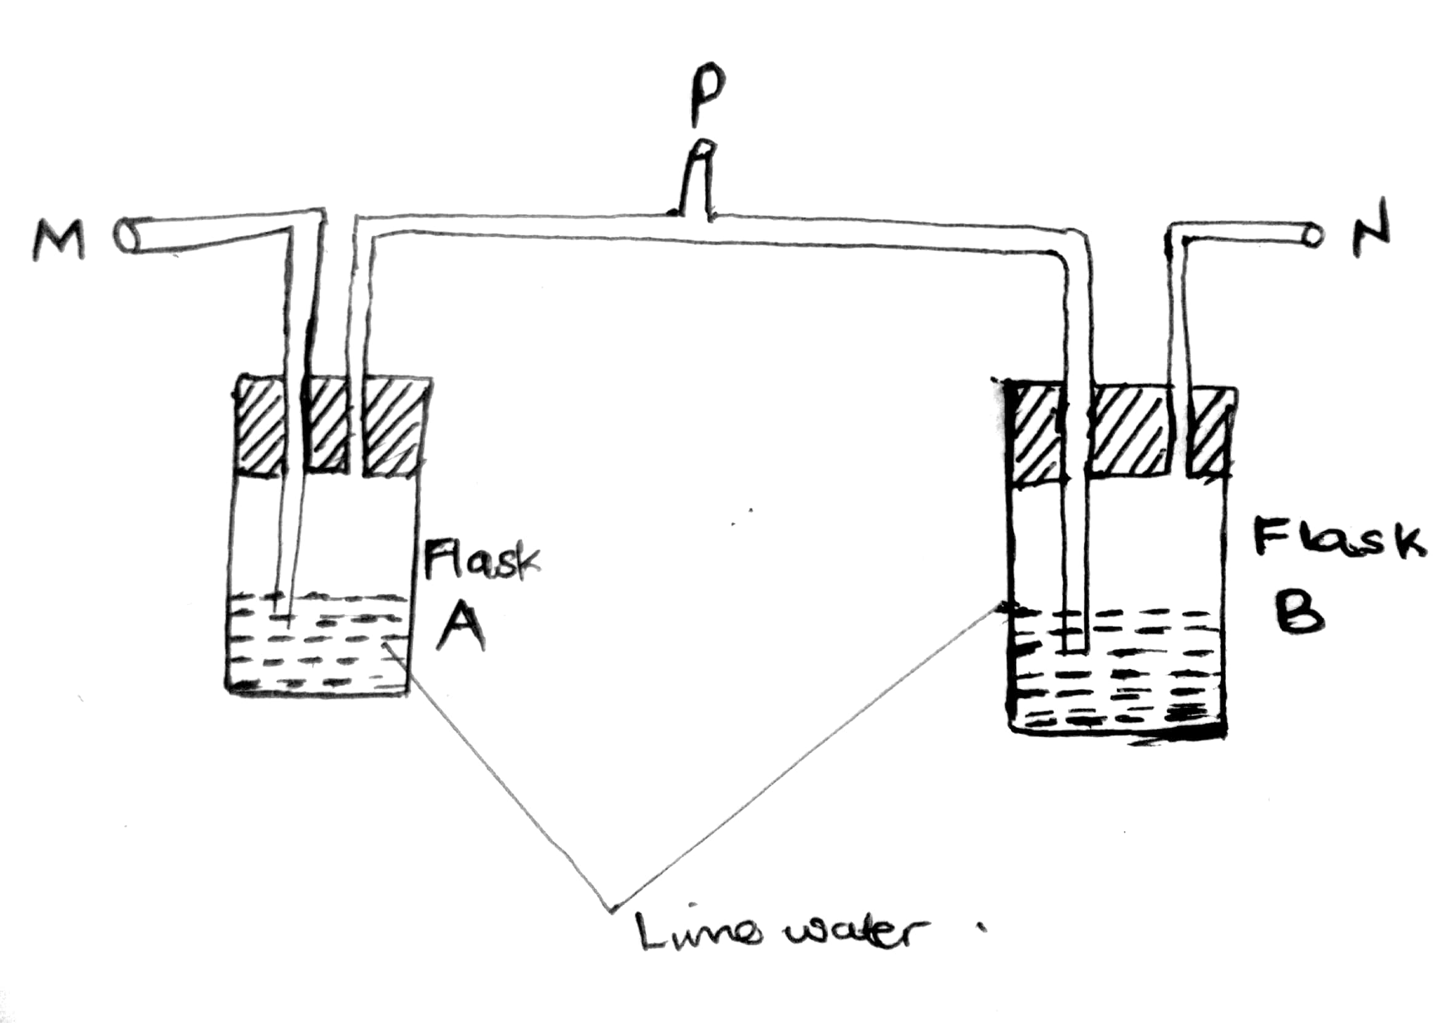
I) Using arrows, show the direction of air movement along tubes M and N on the diagram during the experiment (½mrks)

ii) Suggest the possible aim of this experiment (01mrk)
.....................................................................................................
ii) What results were expected after breathing in and out through tube P several times (02½mrks)
................................................................................................................
...............................................................................................................
..............................................................................................................
.............................................................................................................
3. The figure below shows one of the structure used by an organism to enhance ventilation

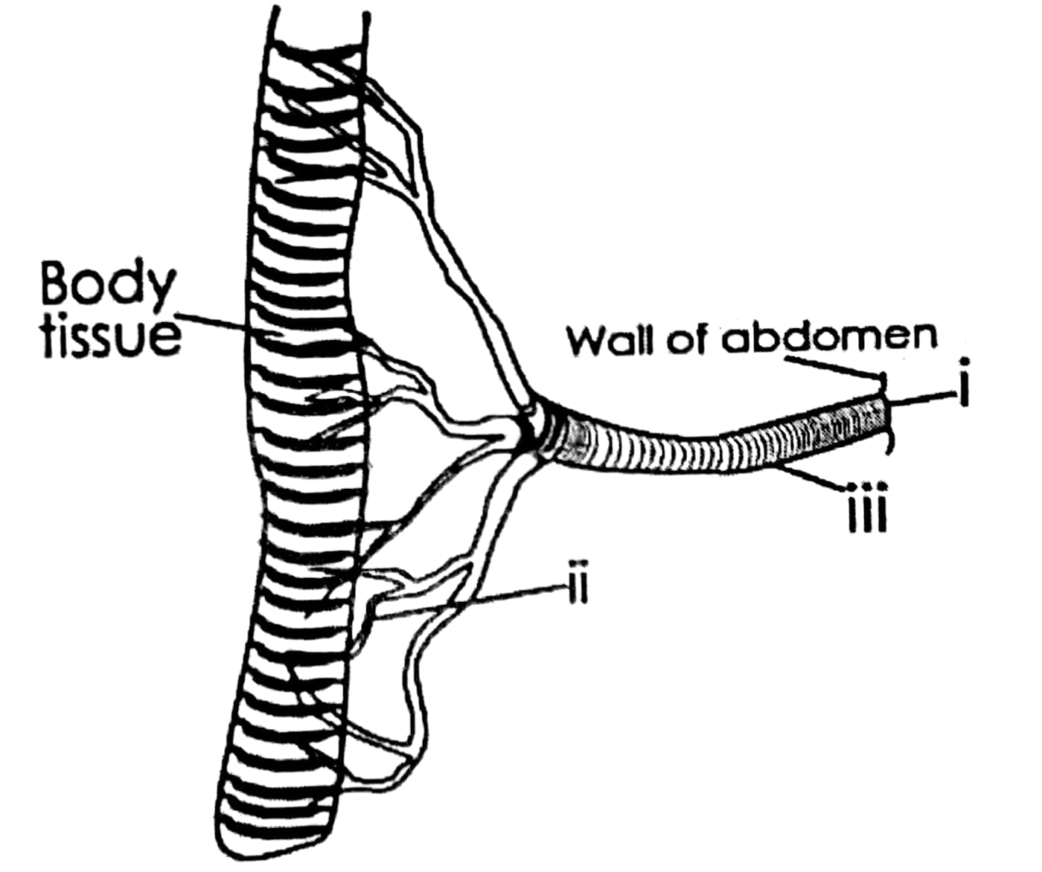

a) Suggest the name the structure (1mrks)
..............................................................................
..............................................................................
b) Name the parts labelled (i) to (iii) (03mrks)
I)..............................................................................
ii)..............................................................................
ii) ............................................................................
c) Basing on the evidence from the structure, explain how it is adapted to its function (03mrks)
.............................................................................................................
.............................................................................................................
............................................................................................................
..............................................................................
d) Describe how air from the atmosphere can reach the body tissues of the organism in the structure (03mrks)
...................................................................................................................
....................................................................................................................
....................................................................................................................

Section c
4. Describe and explain the changes in composition of the following components in inhaled and exhaled air when a person who was previously at rest engages in a vigorous exercise
a) Carbon dioxide (05mrks)
b) Oxygen. (05mrks)
c) Water Vapour. (05mrks)
5. Describe how the following how the following structures are used by the plants during gaseous exchange
a) Leaves (06mrks)
b) Stems (04mrks)
c) Roots (05mrks)
6a).Describe how action of muscles bring about movement of air from the atmosphere into the lungs (7mrks)
b) What are the adaptations of the alveoli during gaseous exchange (08rks)
7a) Describe the characteristics of a good respiratory surface (06mrks)
b) Describe the mechanism of ventilation in a cockroach (09mrks)

